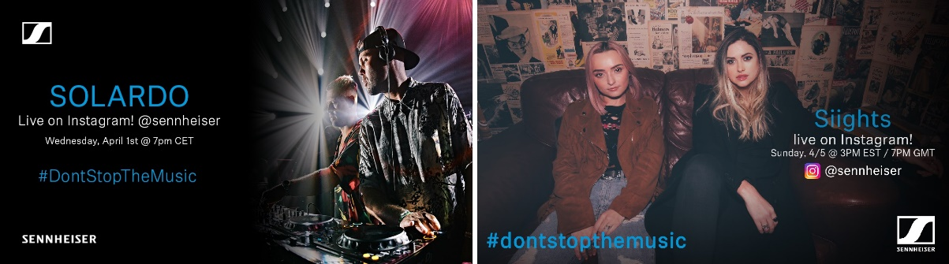

#DontStopTheMusic

International artists continue to entertain stay-at-home audiences with live Instagram gigs

Wedemark/Germany, March 31, 2020 – Sennheiser’s #DontStopTheMusic series is set to see even more artists from around the globe delivering exciting live performances to your home. “We would like to thank all the amazing artists for joining #DontStopTheMusic and playing to their fans – and reaching out to new audiences too – via our @sennheiser Instagram channel,” said Pierre Morant, Head of Relationship Management with Sennheiser. “A special thank-you goes out to the crews who support them, their engineers, management, and social media teams – we are enjoying working with you so much!”

Live concert streams from Wednesday, April 1 to Tuesday, April 7
Within the next seven days, Gestört aber geil, Solardo, Idriss D, Saves the Day (Chris Conley), Kungs, Oso Oso, Delanila, Dogleg, Siights, Bradley Walden, DJ Cutkiller, Willie J. Healey, and Sublime with Rome will all broadcast their performances live via IGTV. Please follow @sennheiser on Instagram and don’t forget to switch on notifications in IGTV to receive alerts, as dates and artists may be subject to change at short notice.

- Gestört aber geil (@gestoert_aber_geil_official):
Wednesday, April 1 at 15:00 UTC (11:00 New York time (EDT), 17:00 Berlin time (CEST), please see note on time zones below)
- Solardo (@solardosound)
Wednesday, April 1 at 17:00 UTC (13:00 New York time, 19:00 Berlin time)
- Idriss D (@idrissdoff):
Thursday, April 2 at 15:00 UTC (11:00 New York time, 17:00 Berlin time)
- Saves the Day (Chris Conley) (@savestheday):
Thursday, April 2 at 20:00 UTC (16:00 New York time, 22:00 Berlin time)
- Kungs (@kungs):
still to be confirmed, please check @sennheiser
- Oso Oso (@osoosoband):
Friday, April 3 at 19:00 UTC (15:00 New York time, 21:00 Berlin time)
- Delanila (@delanila):
Saturday, April 4 at 19:00 UTC (15:00 New York time, 21:00 Berlin time)
- Dogleg (@doglegband):
Saturday, April 4 at 20:00 UTC (16:00 New York time, 22:00 Berlin time)
- Siights (@siights)
Sunday, April 5 at 19:00 UTC (15:00 New York time, 21:00 Berlin time)
- Bradley Walden (of Emarosa) (@bradley.waldon):
Sunday, April 5 at 21:00 UTC (17:00 New York time, 23:00 Berlin time)
- DJ Cutkiller (@djcutkiller)
Monday, April 6 at 16:00 UTC (12:00 New York time, 18:00 Berlin time)
- Willie J. Healey (@williejhealey):
Monday, April 6 at 19:00 UTC (15:00 New York time, 21:00 Berlin time)
- Sublime with Rome (@sublime)
Tuesday, April 7 at 20:00 UTC (16:00 New York time, 22:00 Berlin time)

* A note on the time zones
The concert times are given in Coordinated Universal Time (UTC), with EDT and CEST added for convenience. EDT is short for Eastern Daylight Time, which is four hours behind Coordinated Universal Time. EDT is the time in New York, for example. CEST is Central European Summer Time, which is two hours ahead of UTC – Berlin or Wedemark time, for example.

More music
Please also check out http://www.sennheiser.com/anniversary for the next livestream dates. There’s also a great selection of music videos to watch and listen to, ranging from immersive jazz club recordings, to living room electro sets, to live takes from recording studios. Just put on your headphones (or turn up the speakers) and immerse yourself in the music!

It’s free but why not donate to fight the coronavirus?
At Sennheiser, we’re delighted to be working with these fantastic artists to help spread positivity by putting on exclusive concerts. They’re totally free, but if you do want to say thank you, do consider supporting the WHO in its fight against the coronavirus:
https://www.who.int/emergencies/diseases/novel-coronavirus-2019/donate

For your social media channels:
Enjoy your favorite artists at home and check out the exclusive concerts in Sennheiser’s (@sennheiser) streaming concert series – live on Instagram! #DontStopTheMusic

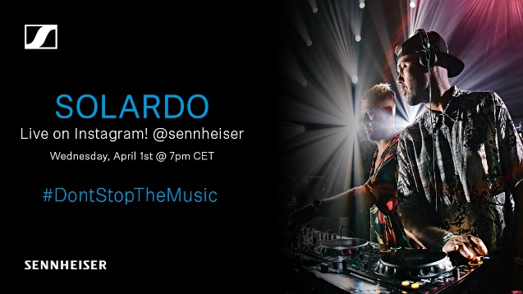 | 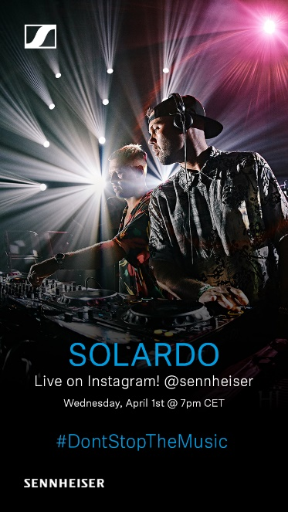
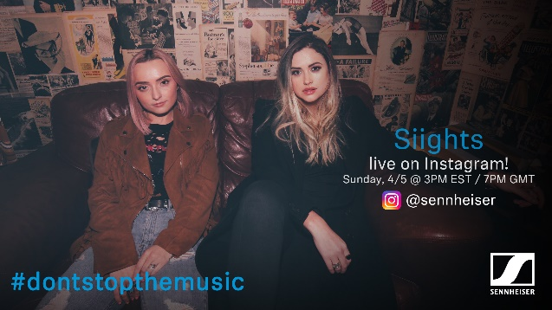 | 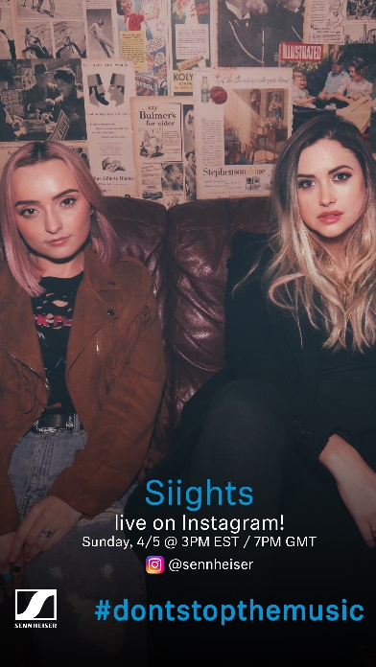

About Sennheiser
Founded in 1945, Sennheiser is celebrating its 75th anniversary this year. Shaping the future of audio and creating unique sound experiences for customers – this aim unites Sennheiser employees and partners worldwide. The independent family company, which is managed in the third generation by Dr. Andreas Sennheiser and Daniel Sennheiser, is today one of the world’s leading manufacturers of headphones, loudspeakers, microphones and wireless transmission systems. In 2018, the Sennheiser Group generated turnover totaling €710.7 million. www.sennheiser.com

Press Contacts

Mareike Oer Stephanie Schmidt
mareike.oer@sennheiser.com stephanie.schmidt@sennheiser.com
T +49 0(5130) 600 – 1719 T +49 0(5130) 600 – 1275

